**Module 8**

1. Develop a PHP web application which demonstrates the process of storing HTML form data into MySQL database.

PHP to connect an HTML form to a MySQL database. We'll use XAMPP as the server software to create a database and run PHP.

We'll use the below steps to create a connection:

1. Set up XAMPP and configure a PHP development environment
2. Create an HTML form
3. Create a MySQL database
4. Create a PHP file
5. Create a connection

**Step 1: Set up XAMPP**

The method to configure a PHP development environment with XAMPP

**Step 2: Create an HTML form and PHP**

This [Answer](https://www.educative.io/answers/what-is-an-html-form-and-how-can-we-implement-it) explains what an HTML form is and how to create it.

|  |
| --- |
| <!DOCTYPE html> |
|  | <html> |
|  | <head> |
|  | <title>Registration Page</title> |
|  | <link rel="stylesheet" type="text/css" href="css/bootstrap.css" /> |
|  | </head> |
|  | <body> |
|  | <div class="container"> |
|  | <div class="row col-md-6 col-md-offset-3"> |
|  | <div class="panel panel-primary"> |
|  | <div class="panel-heading text-center"> |
|  | <h1>Registration Form</h1> |
|  | </div> |
|  | <div class="panel-body"> |
|  | <form action="connect.php" method="post"> |
|  | <div class="form-group"> |
|  | <label for="firstName">First Name</label> |
|  | <input |
|  | type="text" |
|  | class="form-control" |
|  | id="firstName" |
|  | name="firstName" |
|  | /> |
|  | </div> |
|  | <div class="form-group"> |
|  | <label for="lastName">Last Name</label> |
|  | <input |
|  | type="text" |
|  | class="form-control" |
|  | id="lastName" |
|  | name="lastName" |
|  | /> |
|  | </div> |
|  | <div class="form-group"> |
|  | <label for="gender">Gender</label> |
|  | <div> |
|  | <label for="male" class="radio-inline" |
|  | ><input |
|  | type="radio" |
|  | name="gender" |
|  | value="m" |
|  | id="male" |
|  | />Male</label |
|  | > |
|  | <label for="female" class="radio-inline" |
|  | ><input |
|  | type="radio" |
|  | name="gender" |
|  | value="f" |
|  | id="female" |
|  | />Female</label |
|  | > |
|  | <label for="others" class="radio-inline" |
|  | ><input |
|  | type="radio" |
|  | name="gender" |
|  | value="o" |
|  | id="others" |
|  | />Others</label |
|  | > |
|  | </div> |
|  | </div> |
|  | <div class="form-group"> |
|  | <label for="email">Email</label> |
|  | <input |
|  | type="text" |
|  | class="form-control" |
|  | id="email" |
|  | name="email" |
|  | /> |
|  | </div> |
|  | <div class="form-group"> |
|  | <label for="password">Password</label> |
|  | <input |
|  | type="password" |
|  | class="form-control" |
|  | id="password" |
|  | name="password" |
|  | /> |
|  | </div> |
|  | <div class="form-group"> |
|  | <label for="number">Phone Number</label> |
|  | <input |
|  | type="number" |
|  | class="form-control" |
|  | id="number" |
|  | name="number" |
|  | /> |
|  | </div> |
|  | <input type="submit" class="btn btn-primary" /> |
|  | </form> |
|  | </div> |
|  | <div class="panel-footer text-right"> |
|  | <small>&copy; Technical Babaji</small> |
|  | </div> |
|  | </div> |
|  | </div> |
|  | </div> |
|  | <div class="toast" role="alert" aria-live="assertive" aria-atomic="true"> |
|  | <div class="toast-header"> |
|  | <img src="..." class="rounded mr-2" alt="..."> |
|  | <strong class="mr-auto">Bootstrap</strong> |
|  | <small>11 mins ago</small> |
|  | <button type="button" class="ml-2 mb-1 close" data-dismiss="toast" aria-label="Close"> |
|  | <span aria-hidden="true">&times;</span> |
|  | </button> |
|  | </div> |
|  | <div class="toast-body"> |
|  | Hello, world! This is a toast message. |
|  | </div> |
|  | </div> |
|  | </body> |
|  | </html> |

**CONNECT.PHP**

|  |
| --- |
| <?php |
|  | $firstName = $_POST['firstName']; |
|  | $lastName = $_POST['lastName']; |
|  | $gender = $_POST['gender']; |
|  | $email = $_POST['email']; |
|  | $password = $_POST['password']; |
|  | $number = $_POST['number']; |
|  |  |
|  | // Database connection |
|  | $conn = new mysqli('localhost','root','','test'); |
|  | if($conn->connect_error){ |
|  | echo "$conn->connect_error"; |
|  | die("Connection Failed : ". $conn->connect_error); |
|  | }  else  { |
|  | $stmt = $conn->prepare("insert into registration(firstName, lastName, gender, email, password, number) values(?, ?, ?, ?, ?, ?)"); |
|  | $stmt->bind_param("sssssi", $firstName, $lastName, $gender, $email, $password, $number); |
|  | $execval = $stmt->execute(); |
|  | echo $execval; |
|  | echo "Registration successfully..."; |
|  | $stmt->close(); |
|  | $conn->close(); |
|  | } |
|  | ?> |

**Step 3: Create a MySQL database**

In this step, we'll create a simple MySQL database since our server is already running.

We'll open the browser and type <http://localhost/phpmyadmin/>.

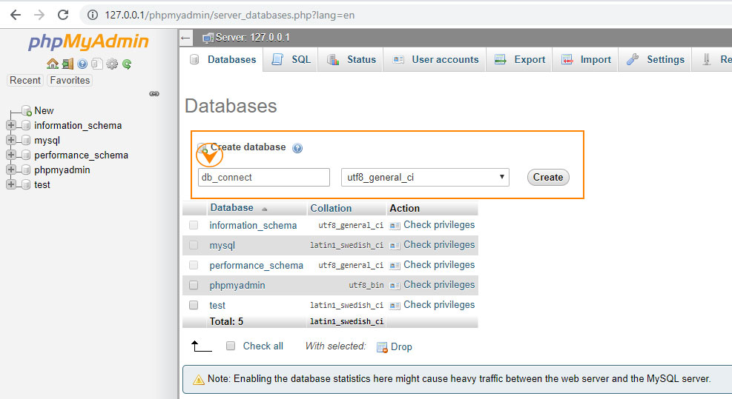

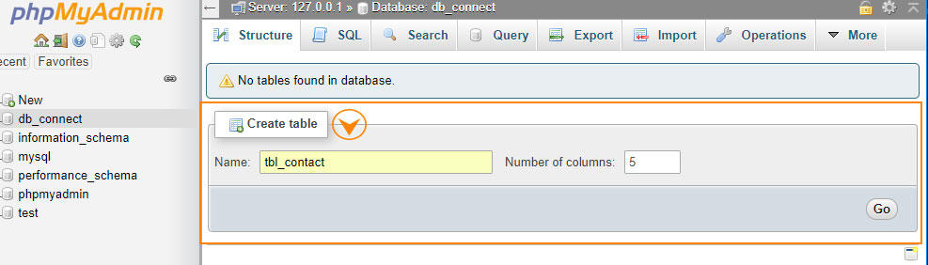

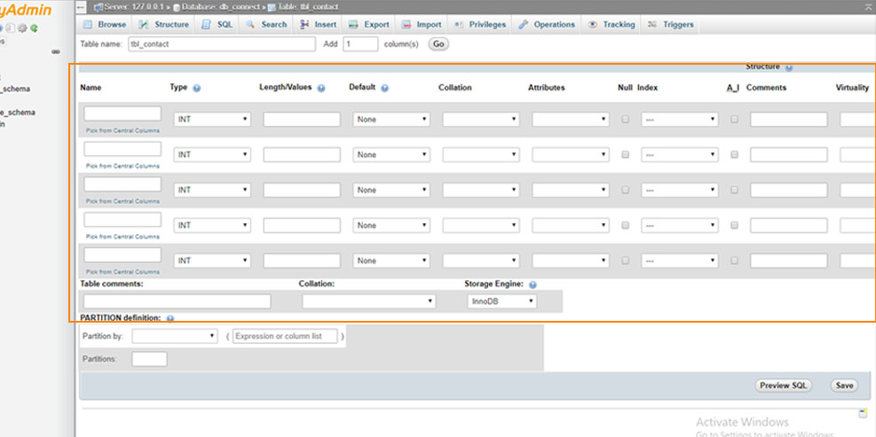

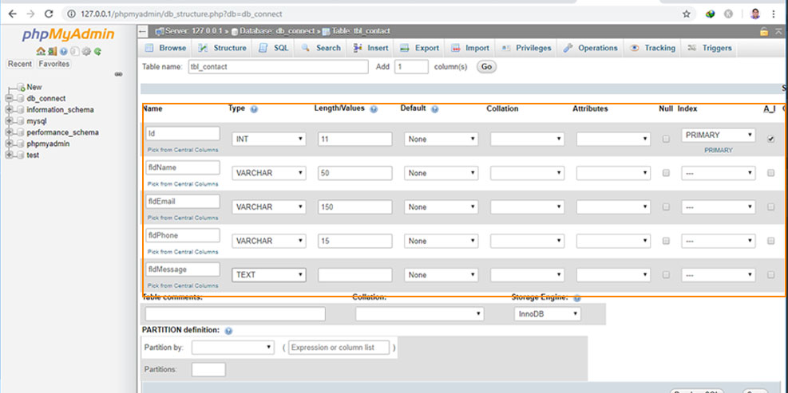

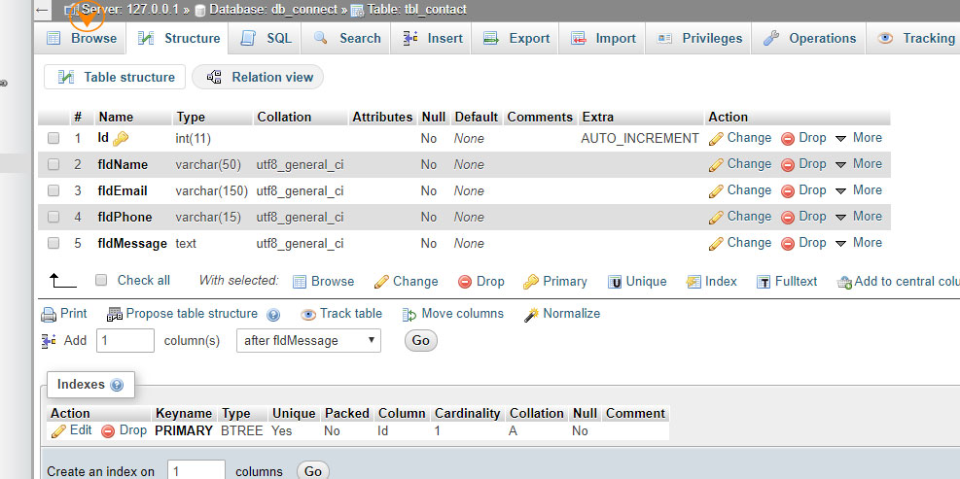

**(b)Develop a PHP web application which demonstrates the process of retrieving table data from the MySQL database and display it in the HTML table.**

## Steps to Display Data From MySQL Database with PHP

You can test yourself to display data with the following folder structure –

codingstatus/

|__database.php

|__table.php

|__developers.php

|

### 1. Connect PHP to MySQL Database

You can use the following database connection query to connect PHP to the MySQL database

* $hostName – It contains host name
* $userName – It contains database username
* $password  – It contains database password
* $databaseName – It contains database name.

File Name – database.php

**<**?php

$hostName = "localhost";

$userName = "root";

$password = "";

$databaseName = "codingstatus";

$conn = **new** mysqli**(**$hostName, $userName, $password, $databaseName**)**;

// Check connection

**if** **(**$conn-**>**connect_error**)** **{**

die**(**"Connection failed: " . $conn-**>**connect_error**)**;

**}**

?**>**

### 2. Insert Data Into PHPMyAdmin Table

Before displaying data, you have to insert data into the Database. If you have not already done it and don’t know about it, then you can learn it through the following URL –

[Insert Data into Database using PHP & MySQL](https://codingstatus.com/insert-data-into-database-using-php-mysql/)

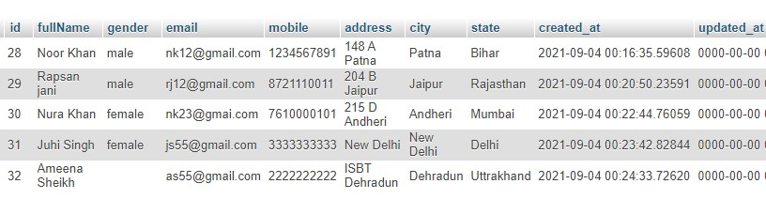

### 3. Fetch Data From MySQL Table

Now, You have to fetch data from the MySQL table. So, just follow these points –

* First of all, include a database connection file database.php
* assign $conn to a new variable $db and table name to another variable $table
* Define columns name in an indexed array and assign them to the $columns
* Also, assign fetch_data() function to the $fetchData

**fetch_data() –**This function accepts three parameters like $db, $table & $column and It contains MySQLi SELECT query that will return  records in an array format by fetching from the database

File name – developers.php

**<**?php

include**(**"database.php"**)**;

$db= $conn;

$tableName="developers";

$columns= **[**'id', 'fullName','gender','email','mobile', 'address','city','state'**]**;

$fetchData = fetch_data**(**$db, $tableName, $columns**)**;

**function** fetch_data**(**$db, $tableName, $columns**){**

**if(**empty**(**$db**)){**

$msg= "Database connection error";

**}**elseif **(**empty**(**$columns**)** **||** !is_array**(**$columns**))** **{**

$msg="columns Name must be defined in an indexed array";

**}**elseif**(**empty**(**$tableName**)){**

$msg= "Table Name is empty";

**}else{**

$columnName = implode**(**", ", $columns**)**;

$query = "SELECT ".$columnName." FROM $tableName"." ORDER BY id DESC";

$result = $db-**>**query**(**$query**)**;

**if(**$result== **true){**

**if** **(**$result-**>**num_rows **>** 0**)** **{**

$row= mysqli_fetch_all**(**$result, MYSQLI_ASSOC**)**;

$msg= $row;

**}** **else** **{**

$msg= "No Data Found";

**}**

**}else{**

$msg= mysqli_error**(**$db**)**;

**}**

**}**

**return** $msg;

**}**

?**>**

### 4. Display Data in HTML Table

Now, You have to display data in the HTML table. So, you have to follow these points –

* First of all, Include PHP script file developers.php
* Create an HTML table using Bootsrap 4
* Check $fetchData is an array or not with if & else condition
* Then apply foreach loop to the $fetchData
* After that print the required data in the table

File Name – table.php

**<**?php

include**(**"developers.php"**)**;

?**>**

**<**!DOCTYPE html**>**

**<**html**>**

**<**head**>**

**<**link rel="stylesheet" href="https://maxcdn.bootstrapcdn.com/bootstrap/4.5.2/css/bootstrap.min.css"**>**

**<**/head**>**

**<**body**>**

**<**div **class**="container"**>**

**<**div **class**="row"**>**

**<**div **class**="col-sm-8"**>**

**<**?php echo $deleteMsg??''; ?**>**

**<**div **class**="table-responsive"**>**

**<**table **class**="table table-bordered"**>**

**<**thead**><**tr**><**th**>**S.N**<**/th**>**

**<**th**>**Full Name**<**/th**>**

**<**th**>**Gender**<**/th**>**

**<**th**>**Email**<**/th**>**

**<**th**>**Mobile Number**<**/th**>**

**<**th**>**Address**<**/th**>**

**<**th**>**City**<**/th**>**

**<**th**>**State**<**/th**>**

**<**/thead**>**

**<**tbody**>**

**<**?php

**if(**is_array**(**$fetchData**)){**

$sn=1;

foreach**(**$fetchData as $data**){**

?**>**

**<**tr**>**

**<**td**><**?php echo $sn; ?**><**/td**>**

**<**td**><**?php echo $data**[**'fullName'**]**??''; ?**><**/td**>**

**<**td**><**?php echo $data**[**'gender'**]**??''; ?**><**/td**>**

**<**td**><**?php echo $data**[**'email'**]**??''; ?**><**/td**>**

**<**td**><**?php echo $data**[**'mobile'**]**??''; ?**><**/td**>**

**<**td**><**?php echo $data**[**'address'**]**??''; ?**><**/td**>**

**<**td**><**?php echo $data**[**'city'**]**??''; ?**><**/td**>**

**<**td**><**?php echo $data**[**'state'**]**??''; ?**><**/td**>**

**<**/tr**>**

**<**?php

$sn++;**}}else{** ?**>**

**<**tr**>**

**<**td colspan="8"**>**

**<**?php echo $fetchData; ?**>**

**<**/td**>**

**<**tr**>**

**<**?php

**}**?**>**

**<**/tbody**>**

**<**/table**>**

**<**/div**>**

**<**/div**>**

**<**/div**>**

**<**/div**>**

**<**/body**>**

**<**/html**>**